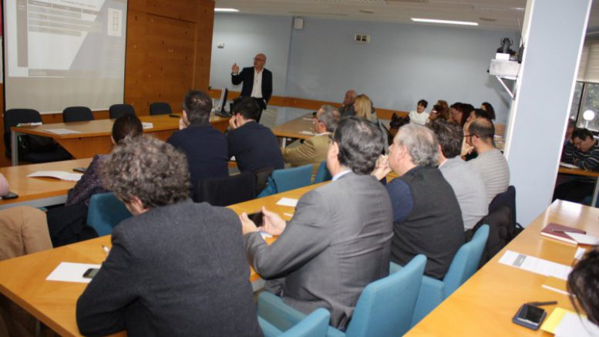
The Ivace and Aidimme will provide arguments for the National Circular Economy Strategy through the TRIS initiative

The Ivace and Aidimme will provide arguments for the National Circular Economy Strategy through the TRIS initiative
POSTED BY: ESTEBAN RODRIGO MARCH 25, 2018
The Valencian Institute of Business Competitiveness, Ivace, and the Aidimme Technological Institute, as representatives of the Valencian Region, are developing the project Transition Regions Towards Industrial Symbiosis (TRIS) together with specialists from four European regions.
It is an initiative that, in addition to the benefits in key areas such as the production and management of industrial waste, efficient production processes, access to innovative production technologies and processes, and the launch of new business lines and new markets, will provide arguments for the future National Circular Economy Strategy.
"The participation of Ivace in the European project TRIS ensures a decisive role of the Regional Administration in the detailed definition and application of this plan in our region," said the general director of Ivace, Júlia Company.
On the other hand, for the person in charge of the project in Aidimme, Manuel Sánchez "the challenges are important, from the scarce knowledge of the companies as much of the possibilities of the industrial symbiosis as of the shared resources in their environment, to the legislative and administrative complications related to the use of waste and by-products ".
Therefore, one of the main actions of the project is to sit down in work sessions (IS labs) to the different competent actors and find ways to overcome these challenges.
Pilot tests during 2018
A specific study on the subject reveals that the 'pan European Industrial Symbiosis' would generate 3 trillion euros in additional sales and cost savings for Europe, along with important environmental benefits, "hence the importance of breaking with the linear model of economic growth, proposing a change towards the circular economy, which tries to close the circle of economic activities taking into account all the phases of the life cycle of a product: from production and consumption, to the management of waste and the market of materials secondary bonuses "explains Sánchez.
Currently, the Ivace and Aidimme are working on the possible completion of pilot tests throughout 2018, with the intention that the development of incentive measures take place in 2019, in areas such as matching the interests of companies, intermediation in industrial areas, feasibility studies prior to the R & D activities and the implementation actions themselves, carried out in the cooperation modality.
What is Industrial Symbiosis?
The 'Industrial Symbiosis' is defined as "the synergistic exchange of waste, by-products, water and energy between individual companies in a locality, region or even in a virtual community".
It is a fundamental component of the circular economy, which improves efficiency in the use of resources and the competitiveness and flexibility of companies.
However, it should not focus exclusively on the use of waste but must take into account other resources such as water and energy, as evidenced by the conclusions of the various meetings of the project, formalized as participatory workshops 'Industrial Symbiosis Lab' , who have reached the 4th call.
This concept, which can be understood as a cooperative use of resources - in many cases waste generated by the companies themselves - still lacks relevant development, and that is why the project seeks the implementation of regional plans that favour its popularization.

