Policy Clinic Report – ZAGREB 12-13 December 2017
The policy instrument:
“Programme for fostering the development of craftsmanship and small and medium sized entrepreneurship in the City of Zagreb.”
The policy clinic theme:
Enterprise (including Start-ups and Entrepreneurship).
The change the city is seeking to make:
Project and structural changes.
The challenge set for the policy clinic:
How to improve the Entrepreneurship’s programme of incentives for entrepreneurs with a particular focus on makers?

List of attendees:

Summary of Policy Clinic Case Studies and Study Visits
DAY 1
- WELCOME AND INTRODUCTION TO THE POLICY CLINIC (City of Zagreb and Birmingham City University).

- PRESENTATION OF POLICY CLINIC CHALLENGE (Miljenko Sedlar)

SESSION 1

- BRAINSTORMING SESSION – MAKERS IN YOUR CITY - Discussion on the types of maker which exist in partner cities and links to Zagreb maker community (led by BCU)

- ZAGREB ENTREPRENEURSHIP PROGRAMME – What is on offer? ( by Nera Pavić)

- BRIEF DESCRIPTION OF THE POLICY FLOW DIAGRAM FOR ZAGREB (Miljenko Sedlar)

SESSION 2
- CASE STUDY VISIT & PRESENTATION – Zagreb Technological Park (by XXXXX) http://www.tehnopark.hr/eng/

- CASE STUDY VISIT & PRESENTATION - Radiona Maker space https://radiona.org/

- GROUP REFLECTION SESSION Partner’s presented their current thinking on Zagreb challenge and for their own city Zagreb responds to initial thoughts and provides clarification on suitability of challenge solutions

DAY 2

SESSION 3

- REFLECTIONS ON DAY BEFORE (Tom Cahill-Jones presentation)

- CASE STUDY VISIT & PRESENTATION - Croatian Maker http://croatianmakers.hr/en/home/

- EACH PARTNERS PROVIDES ONE ACTION FOR ZAGREB

Partner Discussion
Session 1 Summary
Initial discussions on types of city makers – listed below. In conclusion the cities had a number of common areas. Artisans and traditional crafts are unique to each city, the cultural and creative sectors always needed and digital is a thread which could run through it all.
Birmingham | Lisbon | Lazio | Vilnius | Zagreb
Gun makers | Architects | Sculpture | Programming | Crafts – jewellery makers
Buttons | Designers | Aerospace | Visual arts and performing art | Shoes
Jewellery | Communications | High-tech | Visual designs | Umbrellas
Artisan | Arts | cultural heritage | Industrial design | Hats
Printing | Craft – wood/wool/clay/cork (local materials) |  | Craft | Souvenirs
Clay | Architects |  | Cultural heritage | Arts
Wood | Designers |  | Heritage food | Designers
Textile | Communications |  | Recycling
Bio-energy | Arts |  | Tech labs
Digital |  |  | Robotics
Gaming |  |  | Furniture

Session 2 Summary
Zagreb Entrepreneurship programme - Specific Goals
Providing grants, loans and education
Financial support for entrepreneurs
Expert and technical assistance
Development Agency of Zagreb
City Challenges
New models for entrepreneurship financing
Digitalisation (of craft products – the website)
Lacking a maker movement - the policy to support them is lacking

Session 3 Summary
Techno Park
Development agency of Zagreb – public business support organisation. The facility is 100 % funded by the city council.
Technology park – support for SME growth and innovation. It was developed with 2 million euros from city and 2 million euros for equipment and laboratories from ERDF. Many of the labs will be run in partnership with the universities of the city. The Maker space on the ground floor is to be developed in the coming months.

Radiona
Where artists and technologist meet. A Hackerspace - a community oriented space where people with common interests meet.
They are involved in running and organising:
- Workshops
- Exhibitions
- Community products – DIY kit
- EU projects – Erasmus+
- Residencies – makers give the Radiona 1-3 weeks of their time
- Hackerthons
The space is used by students, children, makers, artists, designers, DIY enthusiast, curators, engineers, and ordinary people! The aim is to provide:
- Shareable and collaborative culture via workshops
- Creative and affordable opportunities for everyone
- DIY and DIWO practices including high - low tech integration
- Innovation approaches based on practice and life-long learning
- Cutting edge sustainability

Session 4 Summary
Croatian Maker Case Study
It is run by a special advisor to the president of Croatia on STEM and innovation = CROATION MAKER.
Croatian Maker are working in 500 school using 25,000 robots, so far they have educated 3000 young makers.
They are using micro-bits which enables the children to start coding straight away.
They have started the Croatian maker robotic league.
STEM important but the A is crucial – grit, problem solving skill – creating a path to success.
Internet of things – financed by Croatian internet of things – proof of concept.

Actions and Synthesis of findings

Agreed policy actions for the host city from partner cities

- Birmingham
  - For Zagreb - Route to enterprise using collaborative events. MS are the solution.
  - For Birmingham – valuing the craft sector more

- Lisbon
  - For Zagreb – adapt the entrepreneurship programme to needs of maker spaces, challenges for prototyping and include business planning. Take small steps, pilot projects initially.
  - For Lisbon - Same as Birmingham (and establishing a website for selling craft products).

- Vilnius
  - For Zagreb - Start co-creation process, identify the players and open discussion. Create a platform. Identify common skills and utilise synergy. Advertise and promote programme.
  - For Vilnius - Cooperation with museums – the creative museum

- Lazio
  - For Zagreb - Entrepreneurship programme is good, but needs adapting to makers need i.e. do they need business planning/ marketing? Therefore adapt one of the measures – broaden the programme to suit makers.
  - For Lazio – the product website was of interest and could be replicated.

ZAGREB RESPONSE
- RADIONA – pilot programme could be an interesting approach.
- Recognition that business planning for makers is needed.
- Mapping the maker spaces in the city and the needs of makers would be useful.
- Secondments – buying out time of makers/managers of maker spaces is an interesting suggestion.

BCU Reflections Summary (link back to policy changes and makerspaces)
This section provides BCU’s view on the possible policy changes which could be made based on the three areas of change applicable to the Urban M project: governance, strategy and project.
Policy change through projects
Project 1
Co- design a collaborative event with makers.
Example
Setting up a session with makers, entrepreneurs and policy makers to co-design an event to explore areas of mutual interest. For example a topic could be around strengthening the maker economy.
Result
Ensure makers are engaged in the decision making process of the entrepreneurship strategy for the city.
Project 2
Hold enterprise events at maker spaces
Example
Hold business support events aimed at the general enterprise market at maker spaces.
Result
Expose a wide range of entrepreneurs to different maker spaces around the city and their facilities and create connections between makers and entrepreneurs.
Project 3
Invite makers to run enterprise events.
Example
Support makers to run events to share innovation and technical knowhow to other entrepreneurs in the city. The event should be focussed on a topic to be selected in collaboration with makers.
Result
Shared understanding and opportunities for collaboration.
Project 4
Public information campaign focused on success stories related to makers in Zagreb (and maker spaces).
Example
Promote successful makers through case studies – using social media and other communication methods relevant to the sector.
Results
Raise awareness of maker spaces for businesses and communities. Lower the barriers of entry into the maker community.
Project 5
Secondments – buying out time of maker space personnel to enable them to develop their own sustainable business plans for the maker space and for the benefit of the entrepreneurship programme.
Example
Buying out time of those people running maker spaces, for example the city council undertakes to cover the salary costs of a maker space worker for one day a week for three months, during that time the worker commits to producing a business plan for the sustainability of the maker space.
Results
More specialised support in the maker eco-system for Zagreb’s makers
Project 6
Targeted business mentoring for makers with grants to attend trade fairs locally and internationally.
Example
Support makers to attend local and international trade fairs. The council would undertake to cover travel, accommodation and subsistence, as well as entry fees for a fair in a sector of importance to the council in return would provide evidence of networks established and business leads secured.
Result
Develop routes to market for maker spaces.
Project 7
Commission a piece of research to understand the state of the craft sector in Zagreb.
Example
The research would explore what people make, where it is sold and where it is made as well as how aware the makers are of the emerging sectors and what are their growth ambitions. Emerging sectors could include Internet of Things, VR, mixed reality and robotics.
Result
Would be a better understanding and awareness of emerging market sectors and growth potential. It would enable the council to target investment in the sector effectively.
Policy change through strategic changes
Strategy 1
Establish a prototyping service for the city.
Example
A service where clients make requests to council for help and support and the city matches them to makers who can prototype ideas.
Results
Prototyping service established, business opportunities for makers.
Strategy 2
Hold city led challenge events to tackle issues faced by the local authority.
Example
Challenge events held at the Techno Park, which would provide development grants for winning ideas.
Result
Solutions to challenges developed through the Zagreb innovation eco-system. Where solutions are provided by makers they are made aware of the potential impact of their thinking.
Strategy 3
Investigate how Lazio has established its strategy for start-ups (Go-To-Market).
Example
Lazio’s strategy contains specific measures for makers that could provide inspiration for Zagreb.
Results
A development menu will be established for makers and craftsmen, making clear the stages of the innovation eco-system in the city.
Strategy 4
Visit maker spaces, presenting the existing entrepreneurship programme and identifying areas of misunderstanding.
Example
Ask for feedback from makers on the way in which the entrepreneurship programme is written. Ask them to make clear their understanding. Work collaboratively to write clauses that contain language which resonates with makers.
Results
Makers are more able to engage with the programme.
Strategy / Project 5
Organise maker to maker study visits focused on connecting traditional sectors to emerging sectors.
Example
Traditional crafts connecting with 3d printing technology.
Results
Joint working – develop new methods of production for traditional crafts, sharing knowledge and expertise. Enables makers to determine how their skills could be applied more widely.
Strategy 6
Diversify and grow the business and knowledge base of the Techno Park.
Example
Involve makers in the growth of the Techno Park by providing space and support, ask for perspectives on strategic direction of the facility.
Results
Greater spill over affects between sectors and a stronger eco-system and makers feel able to influence major city initiatives.

Photos of policy clinic and study visit
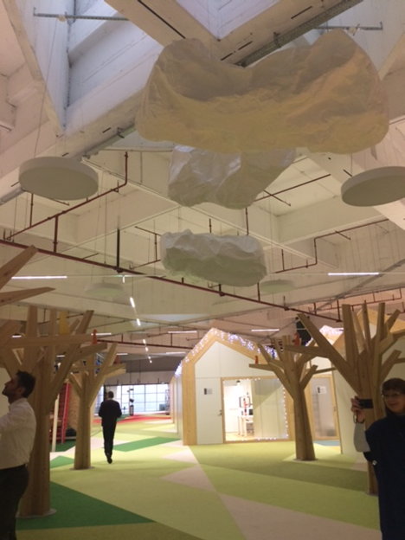
Figure 1 Zagreb Techno Park

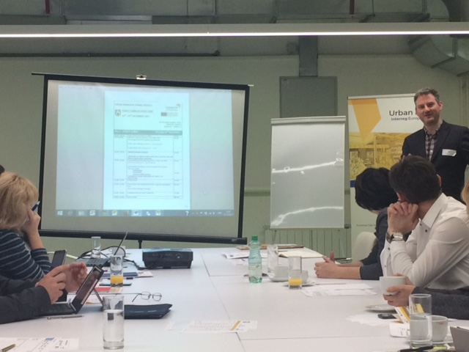
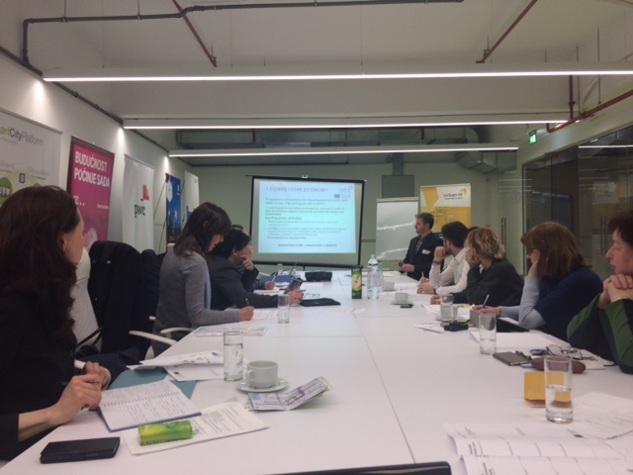
Figure 2 Policy Clinic meeting

