REPORT FROM THE 3rd WORKSHOP IN VALLADOLID 3-4 May, 2017

Between 2nd and 5th of May 2017, at Valladolid, the largest city in Castilla y Leon region in Spain, was held the 3rd interregional workshop of Hericoast, in which were settled mixed teams of different partners to work on the Toolbox and establishing the most appropriate good practices to be used in it.
At the workshop attended all the ordinary partners and stakeholders invited for this event. 26 persons in total participated.
Wednesday 03/05
On Wednesday the workshop debuted with the steering committee talks, where all the ordinary partners pointed their challenges during the semester, and how did they tackled them.
At the end of the session CIVILSCAPE provided a policy briefing for the partners which looks on the European Union and the Council of Europe. Dirk Gotzmann informed on the European Union side about the up-coming European Year of Cultural Heritage, the “Voices of Culture” High-level consultations (see below) and several calls from the actual funding period addressing cultural heritage. In this context the partner were also reminded how to use the two Marinescape Forum events in 2017 and 2018 to meet external experts and promote the outcome of the project. The partners agreed about the focus for both events. Additionally a recent ESPON project works on cultural heritage in the context of spatial and regional planning. One of the authors will present the outcome at the Marinescape Forum Burgas 2019.
On the Council of Europe side, Dirk Gotzmann explained the European Landscape Convention and the different events and institutional bodies involved. From the discussion at the Council of Europe Workshops in Yerevan and the Council of Europe Landscape conference 2017, it seems to possible to draft a recommendation based on the toolbox and the learning experiences of HERICOAST.This could be adopted in the 2019 conference and forwarded than to the Committee of Ministers.
The partners received also a report from CIVILSCAPE about the presentation at the Council of Europe Landscape conference end of March 2017 and especially the reaction of their national representatives about the project.
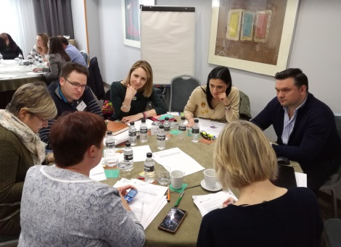
In the second part of the day, Linde Egberts from the project partner VU Foundation/CLUE+ led that part of the workshop assisted by Dirk Gotzman from project partner Civilscape. The group of participants was divided into four working groups. The organisation of the group had been made beforehand based on online survey mapping the competences and interests of each person. The mixed team had as main goal to structure a viable draft for a thematic chapter to the toolbox, focusing on a cohesive structure.
The second part had the following structure:

Before lunch: Getting started
Getting to know each other
Exploring your topic
Structure your thoughts
Formulate a preliminary answer to the main question of your group.
Take notes of these outcomes, they form the bases of your chapter!

After lunch: Evaluate the Good Practices that were grouped with your theme. Based on the outcomes of this morning, what changers would be necessary in order to make them fit your chapter? If Good Practices seem to fit other themes better than our proposal suggests, this is the time to switch. Please keep in mind we need around 4 Good Practices per theme.

The following groups were established:
A | B | C | D
Taking a coastal heritage approach | Creating citizen investment payback | Building Public-private partnerships | Integrating high-scale policy
Cristina Dinu (S) (Tulcea) | Sølvi Christensen (S) (Agder) | Adolfo Colagiovanni (P) (Molise) * | Laura Cuevas Ortiz (P) (Castilla)
Hege Martinsen (P) (Vest-Ager) * | Nekane Irusta (P) * (Leartibai) | Leire Arrizabalaga (P) (Leartibai) | Kåre Kristiansen (P) (Agder) *
Claire McCallan (P) (Donegal) (not present) | Miguelangel Garcia Velasco (S) (Castilla) | Gheorghita Vrinceanu (Tulcea) (P) | Alana Greene (P) (Donegal)
Nora Moberg Lillegaard (S) (Agder) | Luminita Comsa (P) (Tulcea) | Maria San Jose Margareto (Castilla) (S) | Elena Leo (P) (Molise)
Federica Roscioni (S) (Molise) | Concetta Perfetto (S) (Molise) |  | Beatriz Herreras (S) (Leartibai)
Fernando Dies Mediavilla (S) (Castilla) |  | Inigo Uriarte (S) (Leartibai) | Mónica Delgado Villalba (S) (Castilla)
Bidatz Basterretxea (P) (Leartibai) | Leonid Silviu (P) (Tulcea) ** | Andrea Harkin (P) (Donegal)
 |  | Mercedes Cofreces (S) (Castilla)
Translator for stakeholders (Castilla): Ceali Fuentes, José Pérez
Advisor: Linde Egberts, Dirk Gotzmann
'* coordinator of the group.

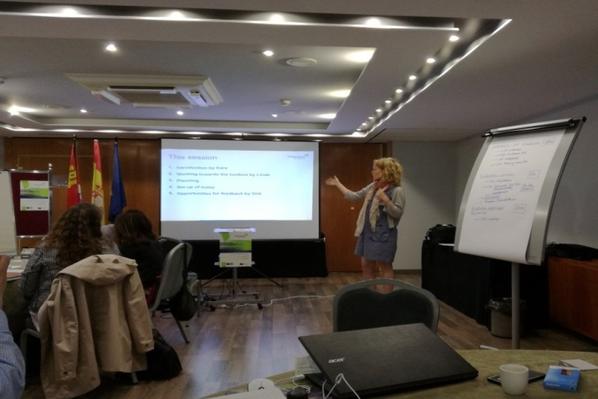

Each of the group were also asked to have look at the following set of good practises examples from other partners that was considered to be relevant for the chapter.
A | B | C | D
Taking a coastal heritage approach | Creating citizen investment payback | Building Public-private partnerships | Integrating high-scale policy
VA Coastlight | VA Preservatio centres | TU Casa Avramide | DO Seacape Character Assessment
VA Lighthouse sign | VA Lighthouse management | MO Orientale
MO Maestrale | JCyL Adeco Tourist Route | MO Albergo Diffuso
LA Lekeitio's heritage experience | JCyL ADECO | LA Territorial economic models
VA Heritage plans |  | CYyL Consortium

Many things went well this time, we had the impression that the project partners and stakeholders liked interacting in smaller groups and having a relatively concrete topic to work on together. This could be a starting point for future workshops as well. The distinction between partners and stakeholders could have been more actively stressed. We received feedback that not all stakeholders were aware of what was expected of them and how their role was different than that of the partners.

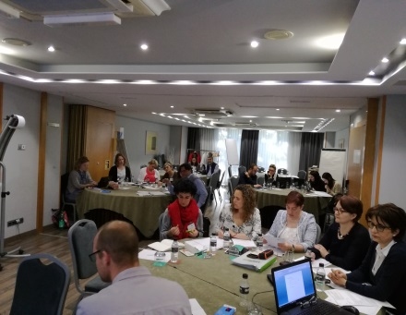
Full agenda:
Tuesday 02/05 Travelling day
19.30 Preparation meeting for workshop leaders
20.30 Welcome & dinner for all partners
Wednesday 03/05
08.30 Steering group meeting 2nd part
11.00 Coffee break
11.15 Workshop: Exchange of good practices
13:30 Lunch break
15:00 Workshop: Exchange of good practises
17.30 Meeting wrap up
20.30 Dinner
Thursday 04/05
8.30 Study visit*: Valladolid-1st stop in the province of Valladolid (estimated time to get there around 45-60 minutes)
11.30 Coffee break
13.00 2nd stop in the province of Palencia (estimated time to get there around 45-60 minutes)
14.00 Lunch
16.30 Arrival in Valladolid
18.30 Additional time for meeting wrap up if needed.
20.30 Dinner
*Two places linked with the good practices provided will be visited. Not approved yet the exact location by the stakehoder group.
Friday 05/05 Travelling day

