Territorial analysis and identification of
DONEGAL

Table of contents
The territorial analysis comprises of the following five steps:

Table of contents 2
1 Landscape and heritage characterisation 3
2 Existing knowledge, material and approaches 3
3 Existing policies on landscape and heritage 9
4 Ongoing policy development processes 17
5 Looking forward to 2018 Cultural Heritage Year 19

1 Landscape and heritage characterisation

Donegal has a distinctive, spectacular and diverse coastline of 1,134km, the longest in Ireland that hosts a rich and varied environment of significant geological, environmental, marine, built, cultural and social resources. This landscape of contradictory types is evident in map no.1 below, illustrating the diverse indented coastline that consists of sea loughs, dramatic sea cliffs, spectacular beaches, sheltered bays, extensive peninsulas and numerous offshore islands, some of which remain inhabited. The character and identity of the coastal area are informed by this unique and contrasting coastine, that in turn inform its defining built, natural, archaeological, historic, marine and cultural heritage.

Figure 1: Landscape types in County Donegal
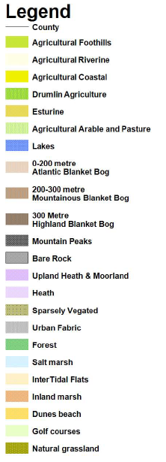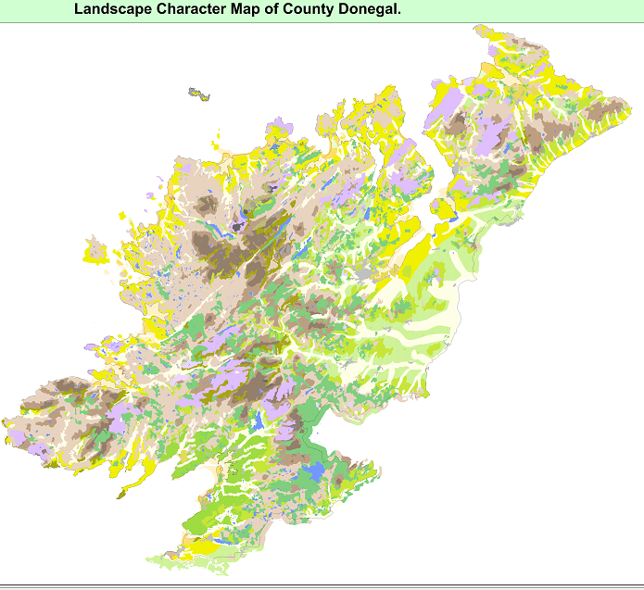
Built heritage in Donegal has a reciprocal relationship with the landscape in all aspects including geographical, natural, aesthetic, social and cultural, with many vernacular structures made from local materials and building methods, structures reflecting the occupation of the British on the Island (including many coastal houses and estates) and also the significant historic, defensive maritime and terrestrial built heritage. Up to 3,500 historic buildings are afforded protection through National legislation; a substantial amount are within 3km of the coastal edge and include, maritime defensive structures, lighthouses, vernacular buildings and industrial economic structures amonst others. Figure 2 below shows the extent of protected heritage assets in the coastal region. A necklace of 99 coastal settlements, including a network of coastal towns, villages, clachans and many more small clusters and communities fringe the coast; these too are informed by and inform the landscape.

Donegal has a rich Archaeological Heritage with a number of sites, artefacts, structures and sites afforded legal protection by their identification in the national ’Record of Monuments and Places’ including 21 archaeological complexes and 2679 monuments and sites. The government has also identified 7 towns within the county that have been designated as ’Historic Towns’, 5 of these are located along the coast. The archaeological asset is further evidenced in historic landscape patterns, settlement location and settlement layout.
Cultural Heritage permeates through all aspects of Donegal and is strongly associated with the perception and identity of the county. The cultural heritage reflects many historic customs and traditions (for example Christian pilgramage routes dating from the arrival of Christianity into Ireland that continue to the present day), including less tangible but evident cultural heritage including poetry, music, oral history, local vernacular customs and notably the widespread use of Gaelic, the native language throughout the county.

Natural and Ecological Heritage is an abundant and valuable asset to County Donegal. The ecological importance is evidenced by the expansive designation of EU protected sites and habitats amounting to 25% of the county’s land coverage (required by EU Habitats Directive (92/43/EEC) and EU (Birds and Natural Habitats) Regulations 2011); the county contains 41 of Ireland’s total of 61 protected European habitats (EU Habitats Directive) and 9 priority habitats. In addition to these EU designations, there are national designations of Natural Heritage Areas (NHAs) and proposed Natural Heritage Areas (pNHAs) for sites that may be significant in biological terms for species, communities and habitats geological or geomorpholocial features or their diversity of natural habitats.

The significant Marine Heritage of the county cannot be overstated; the county has evolved largely from the shore inland due to ease of access. The earliest evidence of settlers to the coast and the first structured settlements are all at coastal locations at sheltered harbours (including Donegal Town, Killybegs amongst others). Likewise commercial and economic developments have historically been located at sheltered landing locations and such examples can be found in Ramelton, Bunbeg, and Buncrana. The abundant fishing waters created an environment for fishing villages around the coast and these too are evidenced in the landscape today at locations such as Greencastle and Burtonport. The fraught military history of Ireland and the strategic location of the County necessitated the construction of numerous coastal defensive structures, many of which remain in the coastal landscape and seascape; as do the lighthouses at the interface with dangerous and hostile Atlantic Coastal waters. The maritime history of the County is an immense asset with a number of projects undertaken to protect and respectively develop such structures and locations as well as engaging the huge potential for their future development subject to sustainable management.

Figure 2: Built, Natural and Cultural Heritage in County Donegal
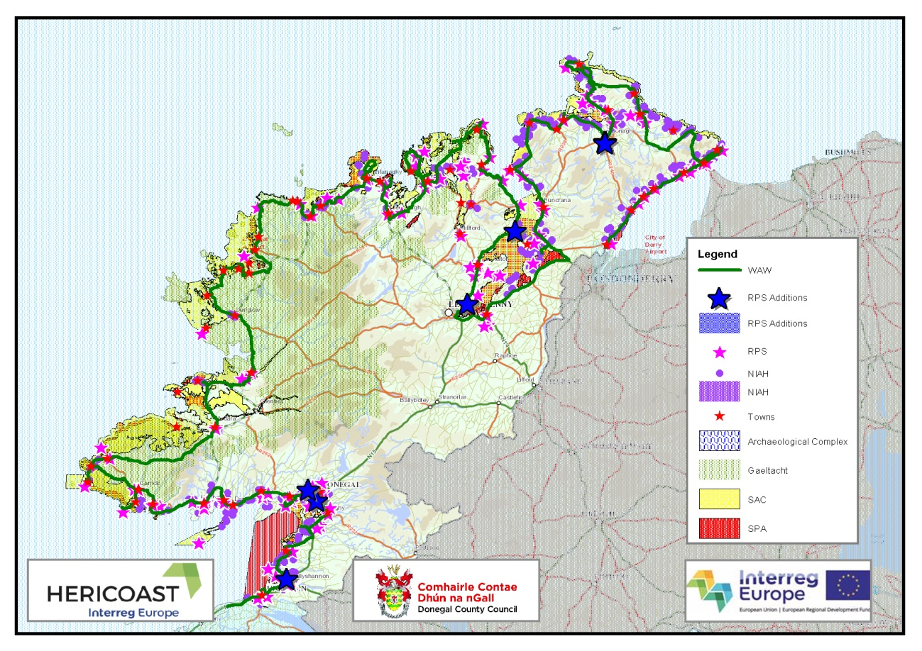
The above Map (Figure 2) includes recent amendments to the Built Heritage of the County that include 127 additions to the Record of Protected Structures in June 2017. The small scale of the map makes it difficult to show these structures individually but more detail on all recent additions can be viewed on the Council’s website at www.donegalcoco.ie .
Coastal and fluvial areas in Donegal are facing differing and immense pressures from a number of factors, including but not limited to:
- the decline in traditional fishing methods
- changes to transport patterns
- the recent growth in the tourism and leisure industry
- Recent national and international accolades including, Readers Travel Awards- voted Donegal as Irelands hidden gem: the No.1 place you think you should know better; National Geographic- Coolest place on the planet; Fanad Lighthouse- voted one of the most scenic in the world; Carrickfin Airport- voted 2nd most scenic landing in the world by ‘private fly’ jet booking service; Wild Atlantic Way (WAW)- voted as ‘best international self-drive route’ by one of the China’s top travel companies using an on-line voting system used by over 10m people; Irish Open 2018 will be in Ballyliffin, again shining a spotlight on the county.
- All of the above accolades have in common the recognition of Donegal’s uniqueness and the quality of its environment and landscape. They have raised the profile of Donegal and highlight its coastal assets that present a great opportunity for further development and economic growth in the County but the associated development pressures must be addressed in a balanced and appropriate way.
- Growth in Cruise ship market.
- Growth in adventure tourism and associated potential negative impacts on the ecological coastal environment.
- Potential damage to the Gaeltacht areas of the county (where Irish is spoken as the first language) through communication in English.
- Climate change and associated sea level rises and resultant flooding.

2 Existing knowledge, material and approaches

A Landscape Character Assessment including a Seascape Character Assessment and Settlement Character Assessment of County Donegal was prepared and published in May 2016. This identified 23 ‘Landscape Character Types’ (LCTs) as per Figure 1, and 44 individual ‘Landscape Character Areas’ (LCAs) illustrated in Figure 3. These LCTs and LCAs were identified following an integrated and evidenced based landscape analysis of the entire region that considered natural, built and cultural analysis at a strategic regional scale. A fundamental tool in garnering this evidence base was the use of interactive digital mapping; this followed through to the extensive public consultation process undertaken whereby an opportunity was given to make written, spatial and photographic submissions to the process. Copies of these documents and a link to the interactive mapping can be viewed on Donegal County Council’s website via the following link: www.donegalcoco.ie (follow path: services/planning/view development plans/ landscape character assessment).

Figure 3: Landscape Character Areas of County Donegal
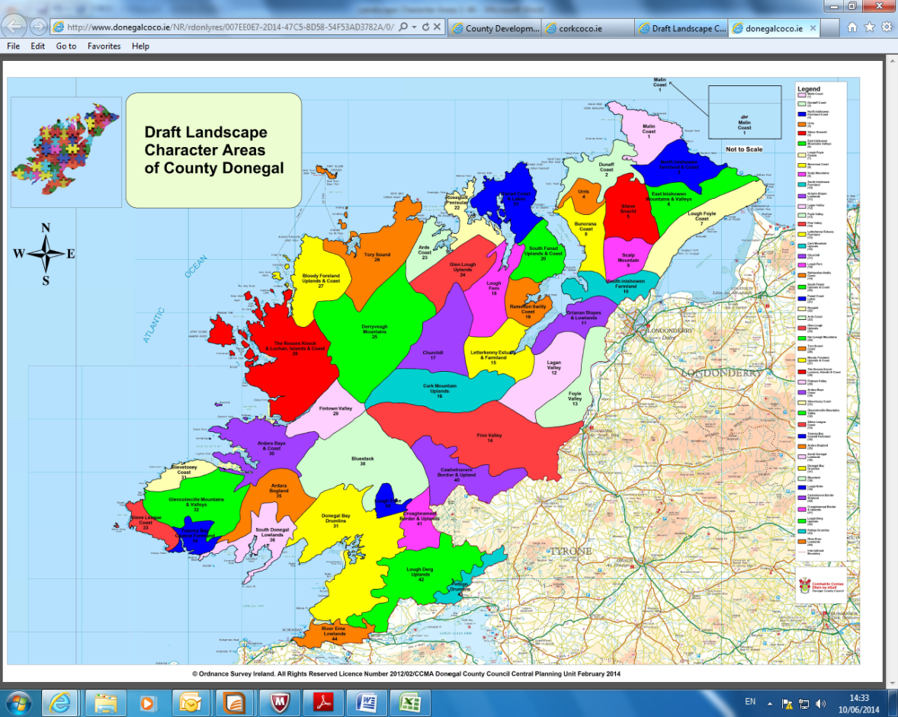
Landscape Character Areas of County Donegal

The Landscape Character Assessment of Donegal classifies and describes the landscape providing an evidence base of the landscape’s components to assist decision making and to achieve a better balance between the protection, management and planning of the landscape in line with the National Landscape Strategy for Ireland 2015-2025 and the European Landscape Convention 2000 (ETS No.176).

Plans and programmes in Ireland are required to comply with Article 6 of the EU Habitats Directive (92/43/EEC) and the EU (Birds and Natural Habitats) Regulations 2011; the Landscape Character Assessment is a narrative of components parts and it is neither a ’plan’ nor policy document in itself and it was therefore not required to carry out a strategic environmental assessment nor an appropriate assessment of this process.

3 Existing policies on landscape and heritage

The current County Donegal Development Plan 2012-2018 contains objectives and policies that pertain to the development of all aspects of the county. The County Donegal Development Plan can be viewed at www.donegalcoco.ie and it is worth noting that the Council are in a 2 year review process will include policy changes, amendments, deletions and additions based on an evidenced based review. A Strategic Environmental Assessment and an Appropriate Assessment are being carried out as part of and alongside this process in accordance with the requirements of Article 6 of the EU Habitats Directive (92/43/EEC) and the EU (Birds and Natural Habitats) Regulations 2011. Likewise the objectives and policies formulated as part of the review of the County Development Plan, have been done in accordance with the requirements of the EU Floods Directive 2007.

The objectives and policies of the existing, operational County Development Plan 2012-2018 are detailed on the table.

Chapter | Objective | Policy
Chapter 6: The Natural and Built Heritage | NH-O-1: To protect, the rich biodiversity of County Donegal for present and future generations.  NH-O-2: To comply with Article 6 of the Habitats Directive (92/43/EEC) and have regard to the relevant conservation objectives, management plans, qualifying interests and threats to the integrity of Natura 2000 sites.  NH-O-6: To ensure where appropriate the protection and conservation of hedgerows, stone walls and traditional field boundaries as natural heritage corridors and migration routes for wildlife where they are shown to play a significant heritage role.  NH-O-8: To protect the character of the landscape where and to the extent that, the proper planning and development of the area requires it, including the preservation of views and prospects and the amenities of places and features of natural beauty or interest.  BH-O-1: To preserve, protect, enhance and record the architectural heritage of the County.  BH-O-2: To facilitate appropriate revitalisation and reuse of the built heritage throughout the county including vernacular buildings.  BH-O-3: To promote economic growth and sustainability through the ongoing regeneration of the built environment.  AH-O-1: To conserve and protect the County’s archaeological heritage for present and future generations. | NH-P-1 It is a policy of the Council to ensure development proposals do not damage or destroy any sites of international or national importance, designated for their wildlife/habitat significance.  NH-P-2 It is a policy of the Council to ensure the protection of Natura 2000 sites in accordance with the EU Habitats Directive (92/43/EEC) and have regard to the relevant conservation objectives, qualifying interests and threats to the integrity of these Natura 2000 sites.  NH-P-3 It is a policy of the Council to require the consideration of Designated Shellfish Waters and their Shellfish Pollution Reduction Programmes in all development proposals that fall within their catchment.  NH-P-4 It is a policy of the Council to require the consideration of Freshwater Pearl Mussel and any relevant Freshwater Pearl Mussel Sub-basin Plans in all development proposals that fall within their basin of catchment.  NH-P-5 It is a policy of the Council to require consideration of the impact of potential development on habitats of natural value that are key features of the County’s ecological network and to incorporate appropriate mitigating biodiversity measures into development proposals.  NH-P-6 It is the policy of the Council to safeguard the scenic context, cultural landscape significance, recreational and environmental amenities of the County’s coastline from inappropriate development.  NH-P-8 It is a policy of the Council to seek the protection of stone wall boundaries where they are shown to play a significant heritage role. Where the demolition of such stone walls is unavoidable, the reinstatement of stone walls at revised location/set back within site using agreed local materials and techniques, will be required.  NH-P-13 It is a policy of the Council to protect and enhance the landscape character and heritage of the Islands.  BH-P-1 It is a Policy of the Council to conserve and protect all structures (or parts of structures) and sites contained in the Record of Protected Structures that are of special architectural, historic, archaeological, artistic, cultural, scientific, social or technical interest.  BH-P-2 It is a policy of the Council to review the RPS on an ongoing basis, and to add structures (or parts of structures) of special interest as appropriate.  BH-P-3 It is a policy of the Council to ensure, where appropriate, measures to extend, modify or materially alter the fabric of vernacular and/ or historic buildings are sensitive to traditional construction methods and materials and do not have a detrimental impact on the character or appearance of a structure.  BH-P-4 It is a policy of the Council to ensure retention of historic structures (and parts of structures), including their functional and decorative details, in accordance with current conservation guidelines and best practice.  BH-P-5 It is a policy of the Council to ensure the repair, reuse and appropriate refurbishment of vernacular/historic buildings, which make a positive contribution to the built heritage of the area including those as referred to on any National Inventory of Architectural BH-P-7 It is a policy of the Council to conserve and enhance the quality, character and distinctiveness of town and streetscapes in the County, considering for example street layouts, building lines, traditional plot widths, signage and historical street furniture.  BH-P-8 It is a policy of the Council to ensure proposals on the Islands will conserve and/or enhance the intrinsic character, scale and visual amenity of the architectural heritage respecting the character of existing buildings, important views and spaces and the historic settlement pattern in terms of scale, height, grouping, density, design and materials  BH-P-10 It is a policy of the council to identify and promote the re-use of traditional building clusters/groupings in both rural and urban settings which add to the unique and specific value of a given landscape character.  AH-P-1 It is a policy of the Council to protect and enhance the integrity of Archaeological Monuments and their settings and to secure the preservation in-situ of all archaeological monuments included in the Record of Monuments and Places.  AH-P-3 It is the policy of the Council to protect the character, settings of and views from National Monuments/ Recorded Monuments and to manage development which would be considered to (visually or physically) intrude upon or inhibit the enjoyment of the amenities of these sites.  AH-P-4 It is a policy of the Council to protect where appropriate, the character and setting of any unrecorded archaeological object or site.
Chapter 7 Natural Resource Development | EX-O-1: To conserve and protect the environment, including in particular, the archaeological and natural heritage and conservation and protection of European designated sites and any other sites, which are prescribed.  EX-O-2: To preserve the character of the landscape where and to the extent that, the proper planning and sustainable development of the area requires it, including the preservation of views and prospects, cultural features and the amenities of places and features of natural beauty or interest.
Chapter 8 Tourism and Marine | TOU-O-1: To develop a range of world-class sustainable tourism products, based on the natural, built and cultural heritage, which provides a core resource for the industry.  TOU-O-2: To support the development of a quality environmental image for the County.  TOU-O-3: To support strong tourism identity areas and create all ancillary facilities necessary for a quality holiday destination.  TOU-O-6: To support educational and research institutions that assist in the development of tourism.  MCZM-O-3: To maintaining high water quality and restore water to high status where it has deteriorated, to improve marine and freshwater habitats.  MCZM-O-4:To maintain and enhance the appropriate and sustainable development of the Islands. | TOU-P-1 It is a policy of the Council to safeguard the natural landscape qualities and environmental habitats of the County.  TOU-P-4 It is a policy of the Council to support the built, natural, cultural and linguistic heritage of the islands, which have significant tourist potential. The Council will also support the development of improved access and telecommunications infrastructure and to assist local island communities to attract tourists.  TOU-P-5 It is a policy of the Council to support the development of indigenous tourism enterprises and community-based tourism initiatives in a manner that meet the principles of tourism sustainability, and that accord with the proper planning and sustainable development of the area.  TOU-P-12 It is a policy of the Council to seek to identify and record important historic Battlefield sites in the County.  TOU-P-14 It is a policy of the Council to promote the Irish language by ensuring that Gaeltacht settlements, which can act as drivers for their surrounding area, are developed in an appropriate and sustainable manner, and in the context of other relevant objectives and policies in this plan.  MCZM-P-10 It is a policy of the Council to manage development proposals, to ensure they do not adversely compromise the recreational and environmental amenity of designated and proposed Blue Flag Beaches, River Basin Management Districts, Special Protection Areas, Special Areas of Conservation, Natural Heritage Areas and areas of Especially High Scenic Amenity.  MCZM-P-11 It is a policy of the council to facilitate development proposals that enhance the sustainability of island communities through their important built, natural, cultural, marine, archaeological heritage and economic assets and opportunities, in the context of the proper planning and sustainable development of the area.  CCG-P-26 It is a policy of the Council to facilitate the appropriate development of cultural tourism products, which harness existing linkages across the County with regard to history, geography, economic development, folk traditions, language and musical heritage as well as activity based and marine tourism subject to the availability of necessary infrastructure, any environmental designations and in line with the proper planning and sustainable development of the area.  CCG-P-27 It is a policy of the Council to promote the Irish language by ensuring that Gaeltacht settlements, which can act as drivers for their surrounding area, are developed in an appropriate and sustainable manner, and in the context of other relevant objectives and policies of this plan.
Chapter 9 Community, Culture and Gaeltacht | CCG-O-1: To integrate the planning and sustainable development of the County with the social, community and cultural requirements of its population.  CCG-O-4: To facilitate the continuing promotion, protection, harnessing and sustainable development of Culture as a resource in the County with due diligence for environmental considerations.  CCG-O-6: To continue to promote the appropriate and sustainable linguistic, cultural, social, physical and economic development of the Gaeltacht subject to normal planning & environmental considerations and to maintain the primacy of the Irish language and its associated culture.

4 Ongoing policy development processes

The draft National Planning Framework ’Ireland 2040- Our Plan’
The draft National Planning Framework ’Ireland 2040- Our Plan was published earlier this year for consultation and when adopted, will be an expression of government policy for national, regional and local planning and investment decisions for the years ahead.

Border Regional Planning Guidelines 2010
The Border Regional Planning Guidelines are under review at present. These guidelines set out a coherent growth and development strategy for the north west geographical regions of Ireland.

County Donegal Development Plan 2012-2018 (as varied)
The County Donegal Development Plan 2012-2018 (as varied) aims ‘to conserve, protect and enhance the County’s built, natural and cultural heritage for future generations and encourage appreciation, access and enjoyment of these resources’ through the policies and objectives highlighted in table 1 above. The review of the County Donegal Development Plan gives an opportunity to further refine heritage objectives and policies throughout the county including those specifically related to coastal and fluvial heritage.

Local Economic and Community Plan (LECP)
The LECP sets out a series of Goals and Objectives for the development of the County. The Goals are cross-cutting in nature and relate in various ways to economic and community needs within the county. Cascading from this are a series of high level objectives to deliver integrated goals.

The Goals and Objectives pertaining to Heritage elements are set out below.

Goal 2: To Harness Donegal’s Natural & Human Capital
- Built Heritage | To protect and enhance the built heritage of the County as a valuable expression of natural and human interactions.

Goal 3: To Value, Sustain and Develop Our Culture and Creative resource
- Landscape Informing Heritage | To recognise the importance of the Donegal landscape in informing culture.
- Built Heritage | To protect and engage with County Donegal’s built heritage as an integral component of our culture.

Goal 7: To Promote Entrepreneurship, Investment and Enterprise
- Built & Cultural Heritage | To unlock the potential of the built and cultural heritage of County Donegal.

County Donegal Heritage Plan 2014-2019
The primary aim of the County Donegal Heritage Plan is to ‘raise awareness, understanding and appreciation of the rich and diverse heritage of our county; to promote its conservation, enhancement and enjoyment; and to sustainably harness the economic, social and cultural benefits of heritage for current and future generations.’

The County Development Plan and the County Heritage Plan are interlinked yet standalone heritage documents pertaining to the appreciation, conservation and development of heritage throughout the county. It is intended to develop an action plan for heritage from this basis to create a more coherent, holistic and linked method for heritage planning in the region.

5 looking forward to 2018 Cultural Heritage Year

The Heritage Officer of Donegal County Council is working closely with the National Heritage Council in the formulation of events and actions towards improving awareness, protection and management of the county’s extensive heritage assets, in the context of the European Year of Cultural Heritage 2018. The HERICOAST project team are continuing to work in parallel with the Heritage Officer on this.

